- Storage Accounts:

To setup file systems.
Two types of storage accounts.
- Azure Blob service
- Azure datalake Gen2

Difference:
- Azure Blob service:
-> hierarchical namespace is disabled.
-> best for write once and rarely read it. (backup scenarios).
2. Azure datalake gen2
-> Hierarchical namespace is enabled.
-> best for write once and read frequently. (regular usage)

Portal.azure.com

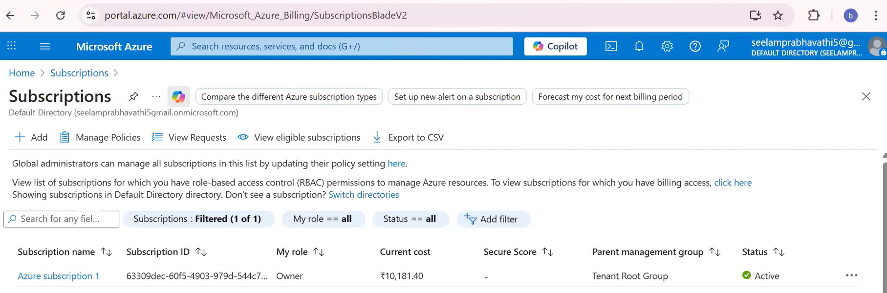

Step1:
Create resource group.
--> is a collection of resources.
Resource : is a Azure service or 3rd party services.
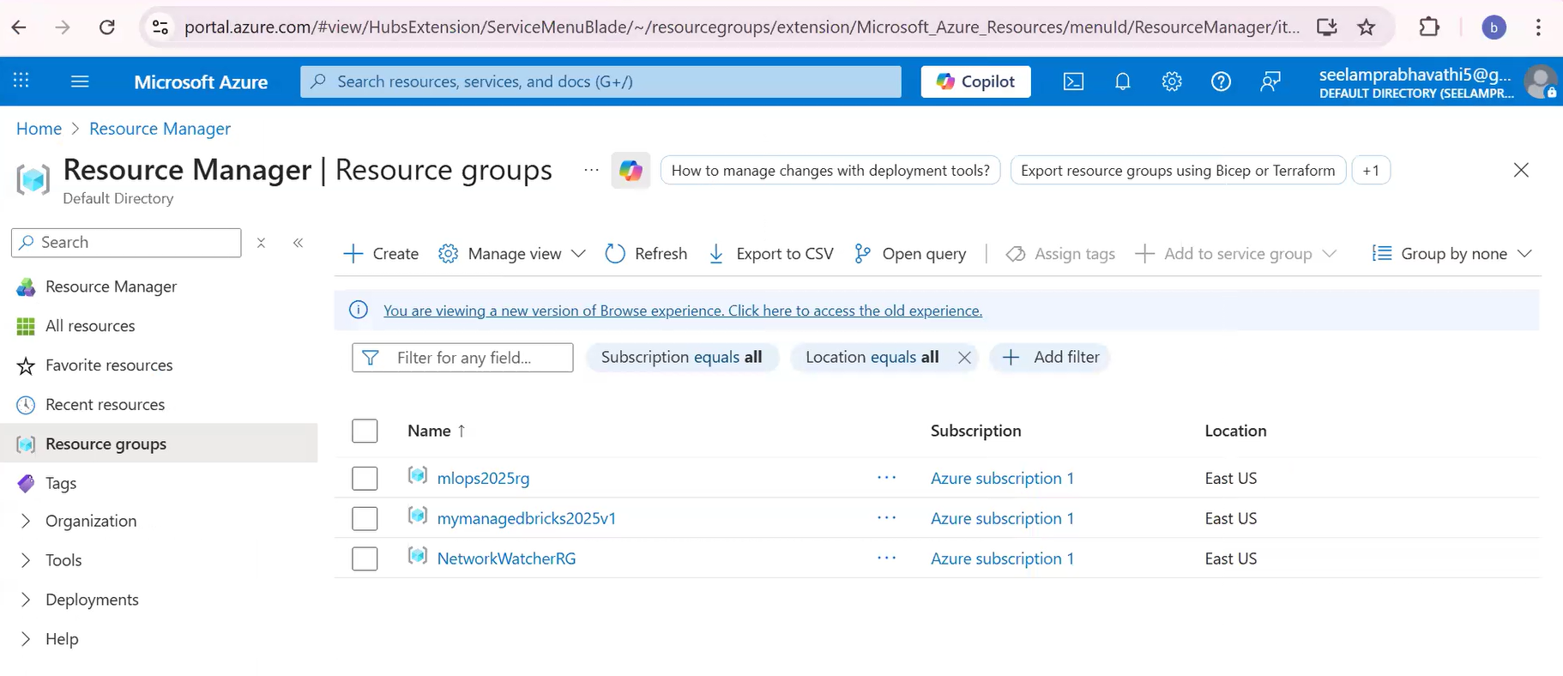
Click on “+Create”
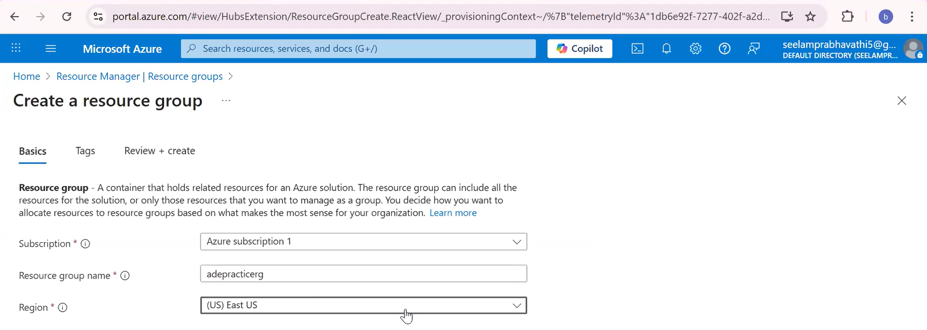

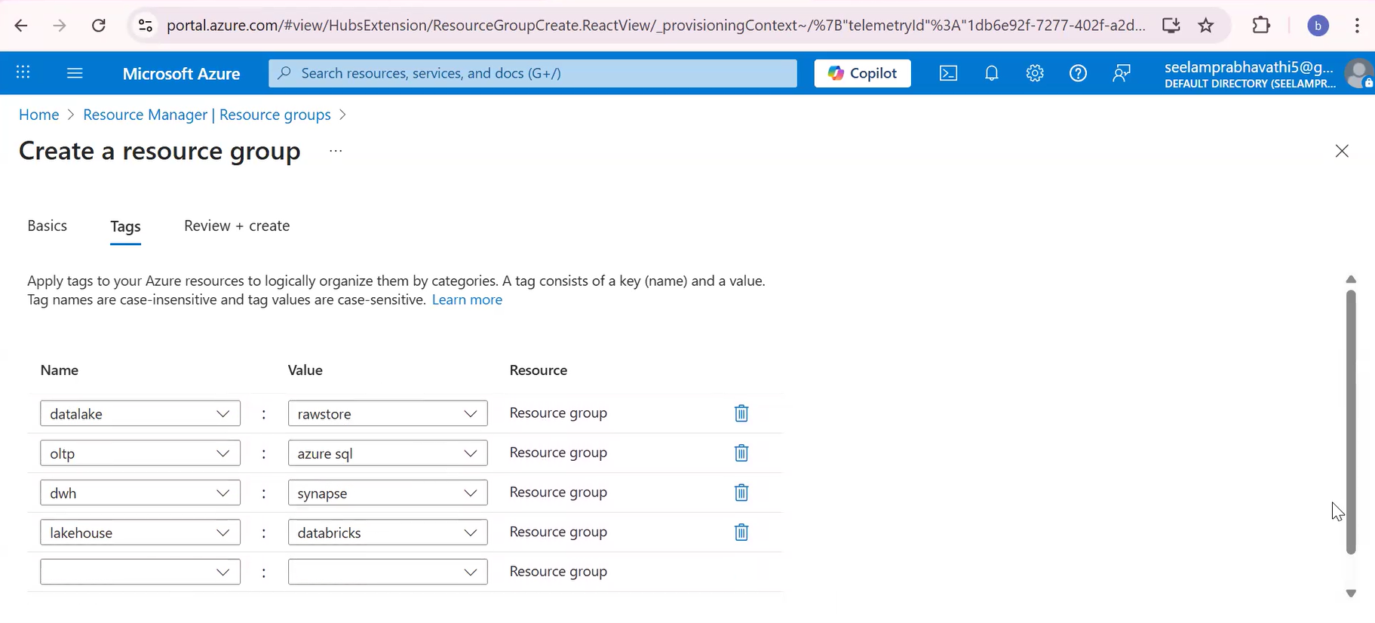
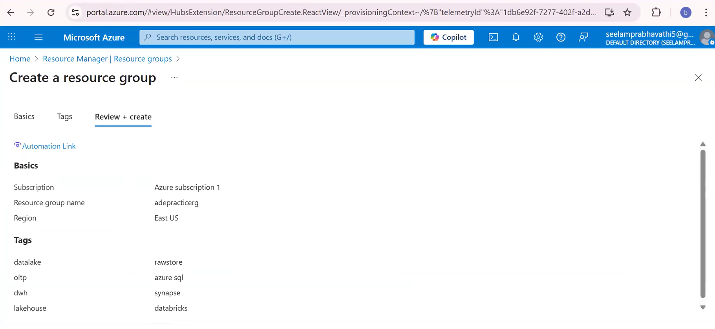

Click create button to create
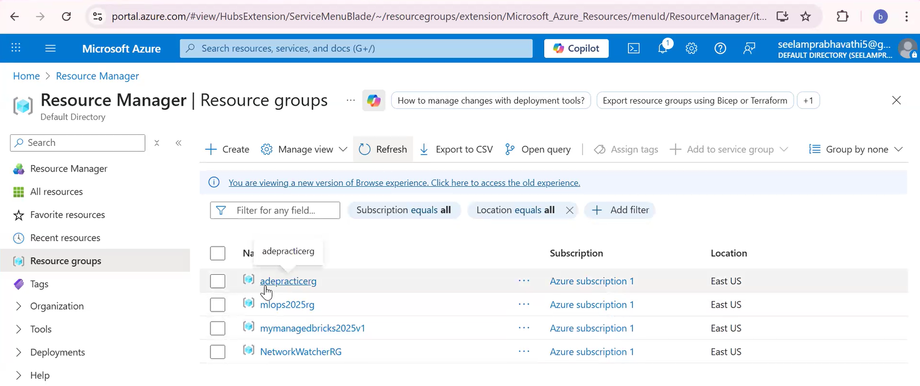
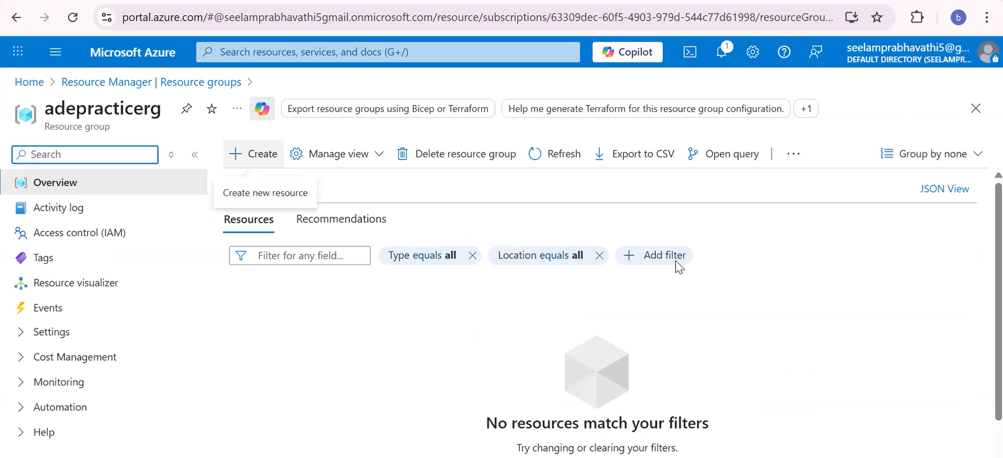
+Create
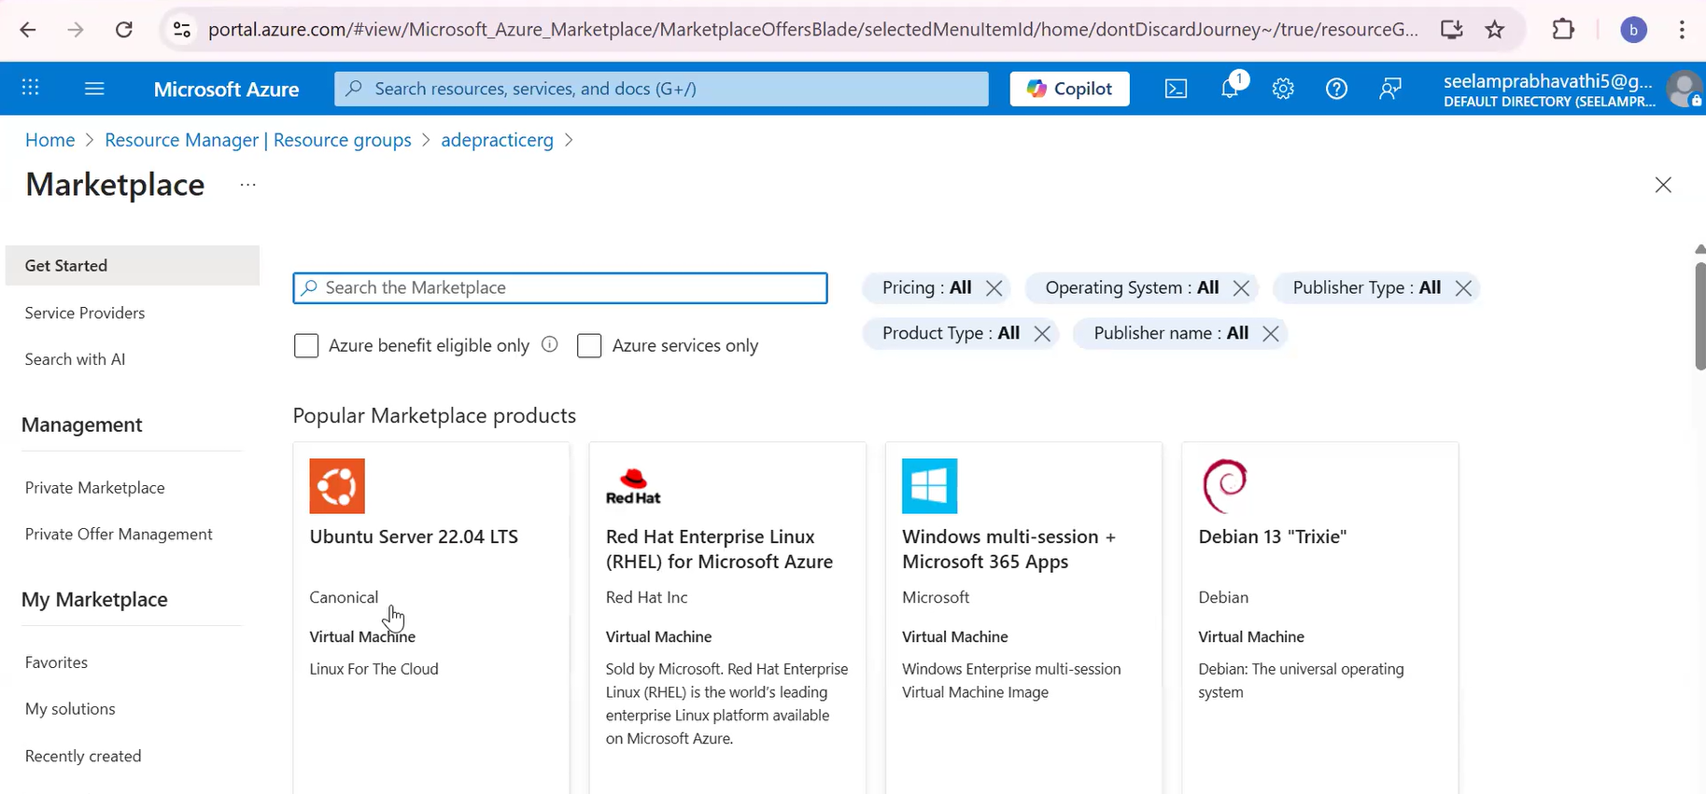

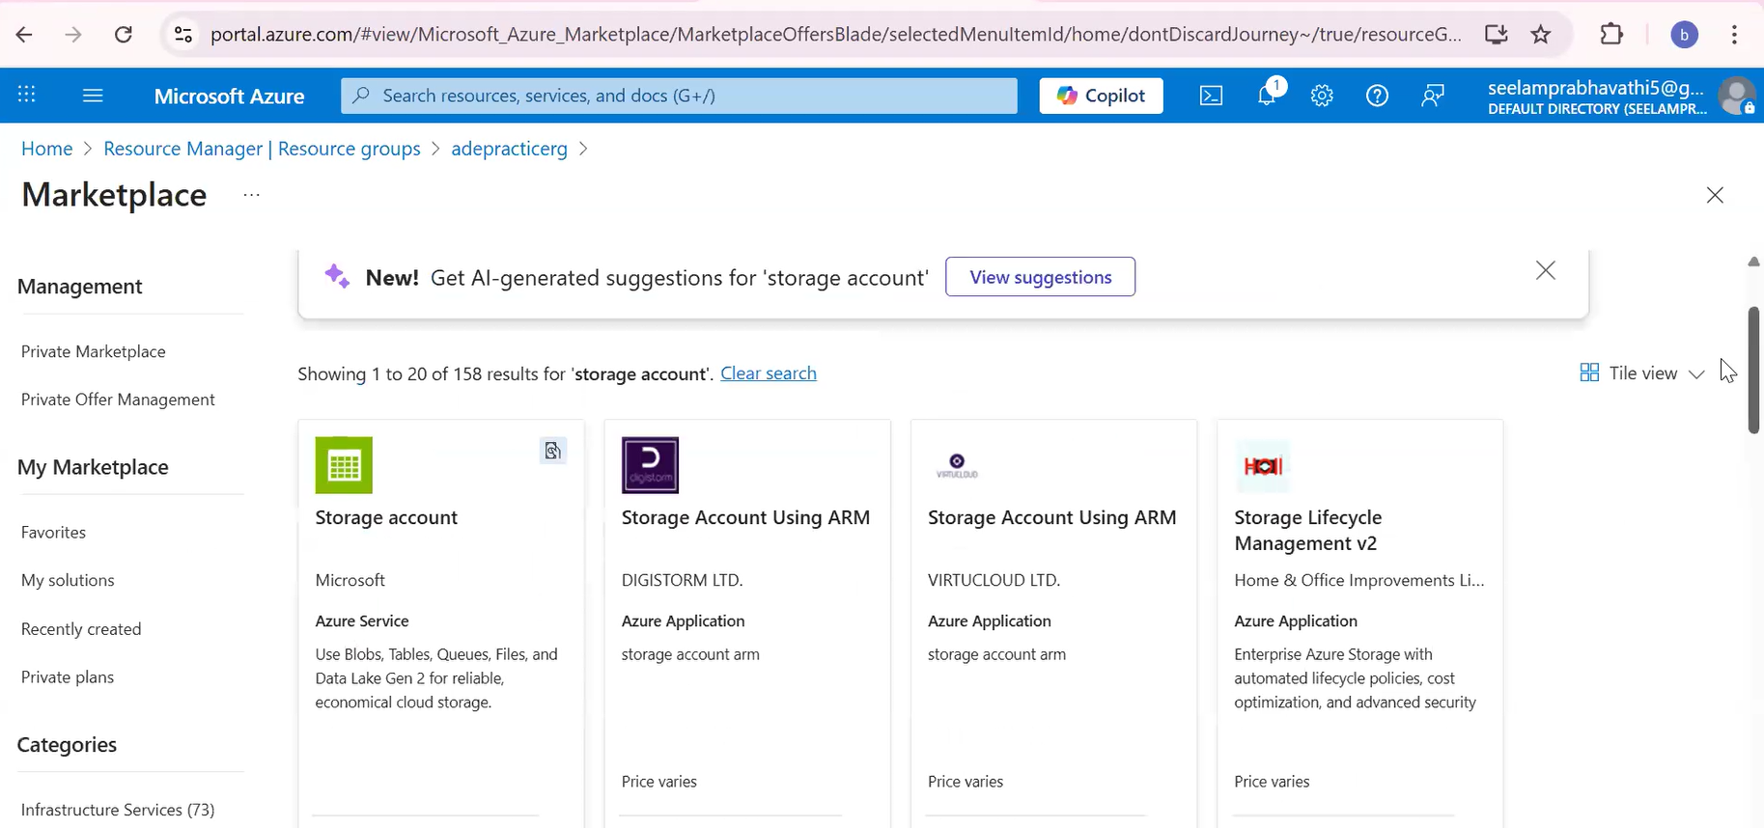

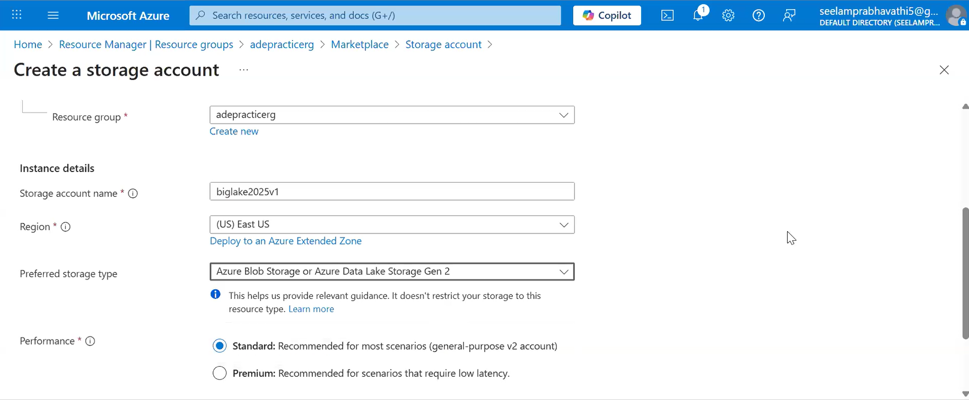

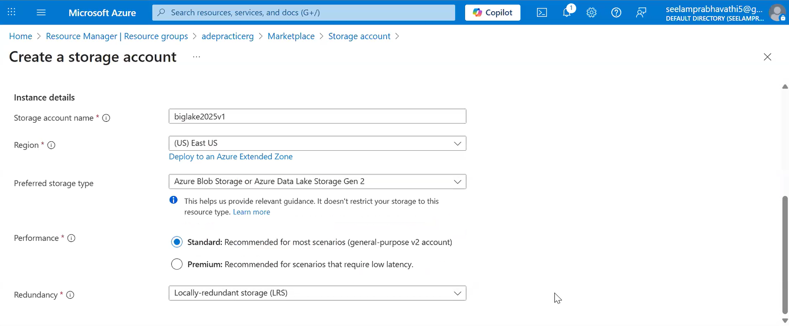

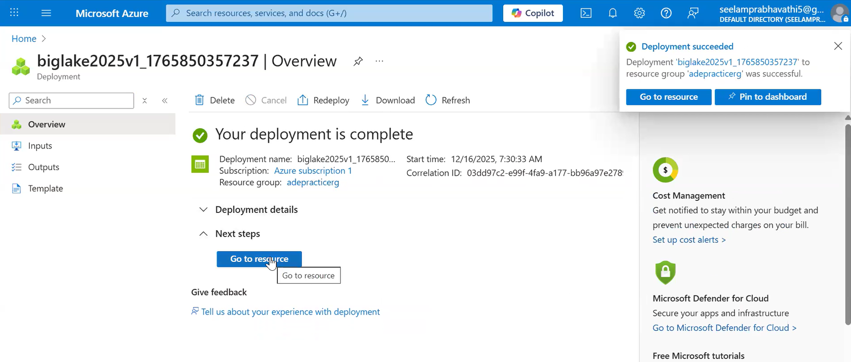
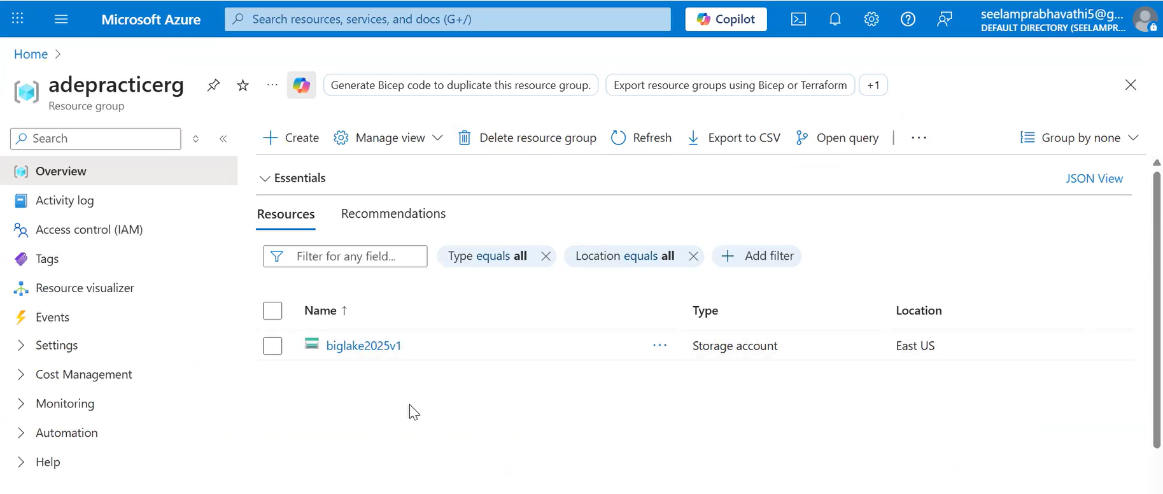

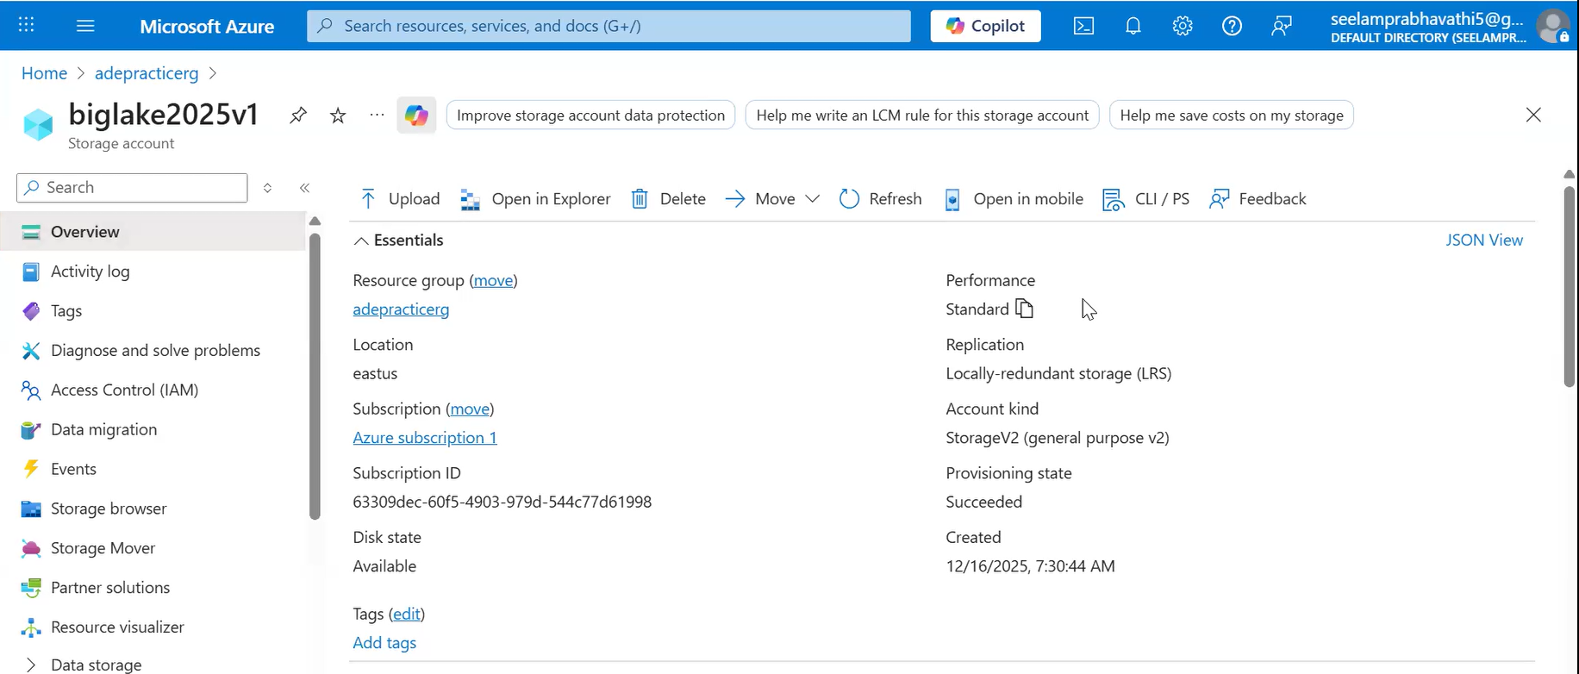

Repeat the steps to create Azure datalake gen2 by enabling the Hierarchical namespace.

